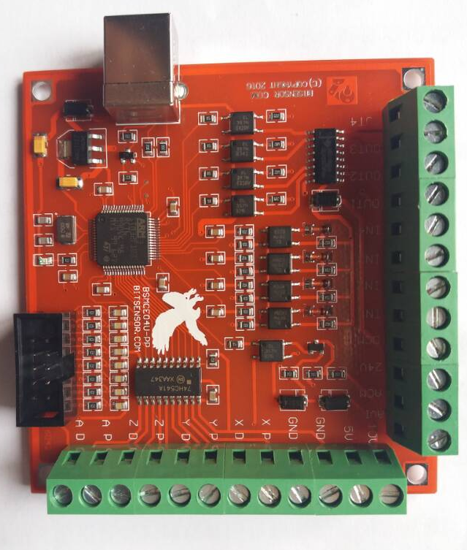

Mach3 Software Installation

When you purchase our product, we will supply a CD-ROM, which contains the MACH3

installation, registration, and USB plug-ins. See as Figure 1-1

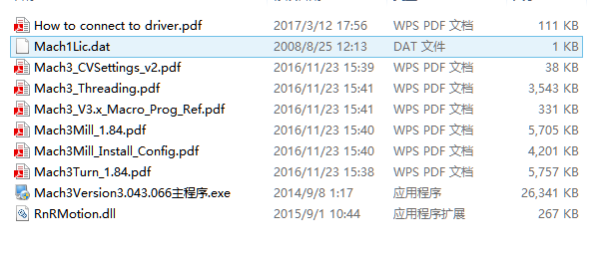

Figure 1-1

First run the installation Mach3Version3.043.066 .Into the first page. See as Figure 1-2.

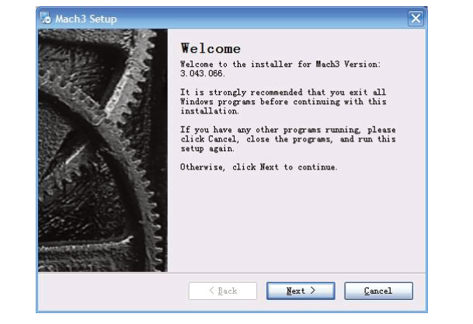

Figure1-2. MACH3 installation process 1

Click Next and then enter the page shown in Figure 1-3

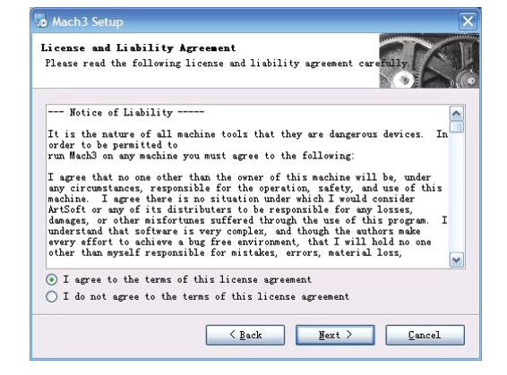

Figure1-3. installation process 2

Select I agree and click Next，See as Figure 1-4.

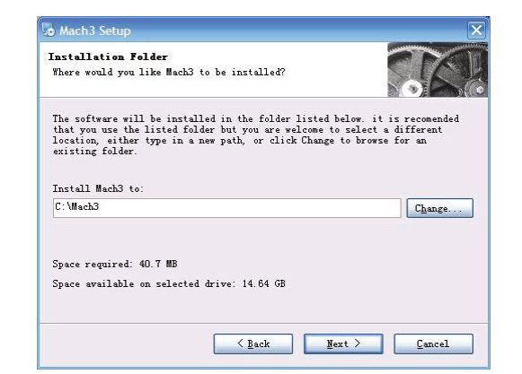

Figure1-4. MACH3 installation process 3

Select the installation path, click Next (it can be installed on any disk, and recommended to

install the C drive or the D drive) See as Figure 1-5

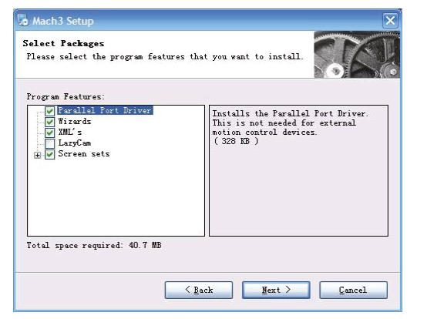Figure3-5. MACH3 installation process 3

Click Next until completion. Then restart the computer.

1.2. MACH3Registration

Copy the file Mach1Lic.dat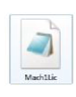 in The CD-ROM to mach3 installation path (eg

C:/MACH3).

1.3. USB Mach3 Plug-in installation

Copy the file RnRMotion.dllIMG_256 to X:\Mach3\PlugIns，X is the disk where the soft is installed.

Using of software

2.1. Open software

Double-click the mach3mill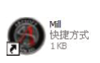

Enter mach3 software. Pop-up the plug-in dialog box. See as Figure 2-1.

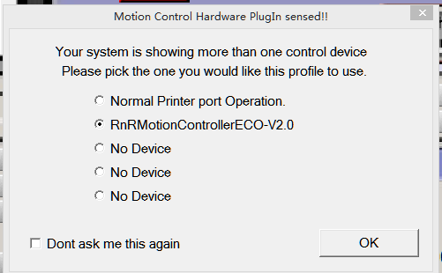

Figure 2-1

Figure 2-1. Plugin selection dialog

Choose our plugin RnRMotion-PlugIn---Ver-2.0a。Then press OK. If you do not want

to the dialog box appear again next time, you can select Don’t ask me this again.If connect

successfully,Status bar will show “RnRMotion device is connected to your computer”.

2.2. Software Common settings

4.2.1 Check RnRMotion plugin

Click config plugins to input PluginConfig,you can see RnRMotion. See as Figure2-4.

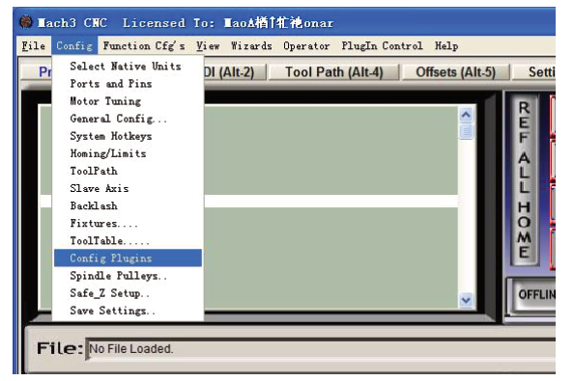

Figure 2-4. RnRMotionPlguin

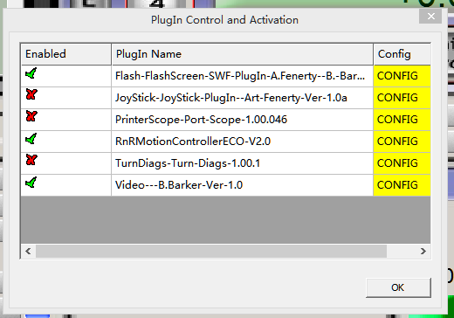

Figure 2-4. RnRMotion Plguin

2.2.1Motor operating parameters setting

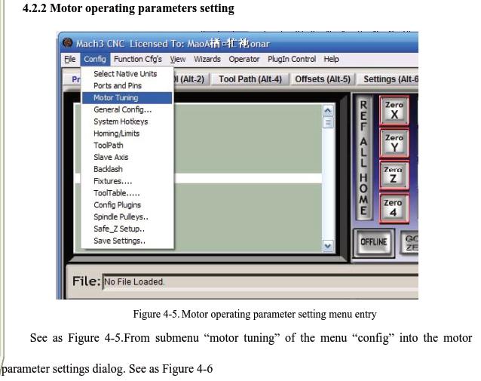

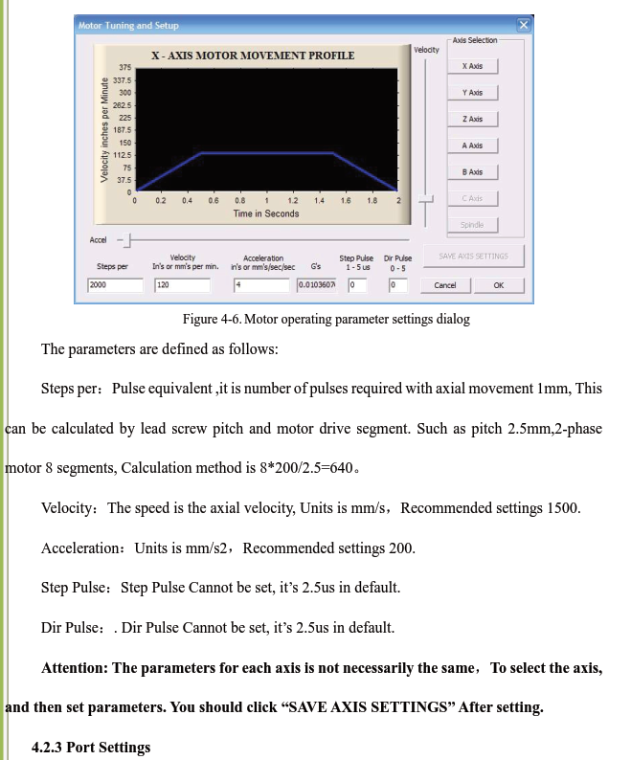

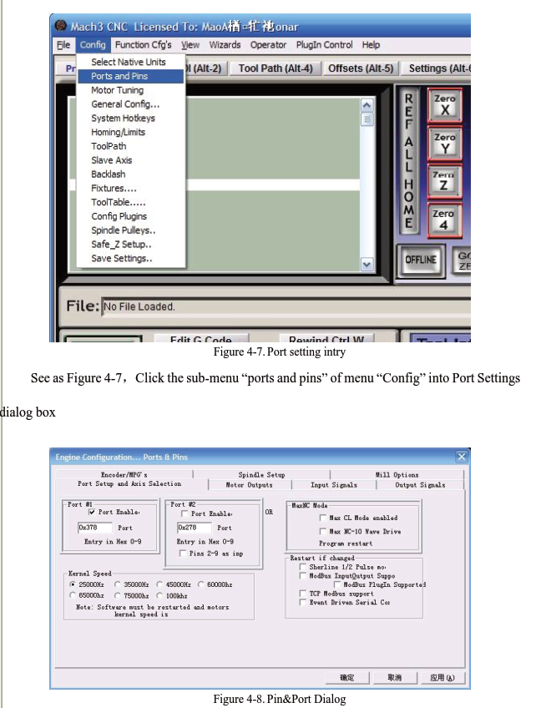

The sub-pages you need to set include “Motor Outputs”, “Input Signals”, “Output Signals”

and “Spindle Setup”.First Click to enter “Motor Outputs”. This page is to select the stepper motor control pin. Because our usbmach3 interface board stepper motor signals are fixed, So here only need to Select, no need to select the specific pin. See as Figure4-9

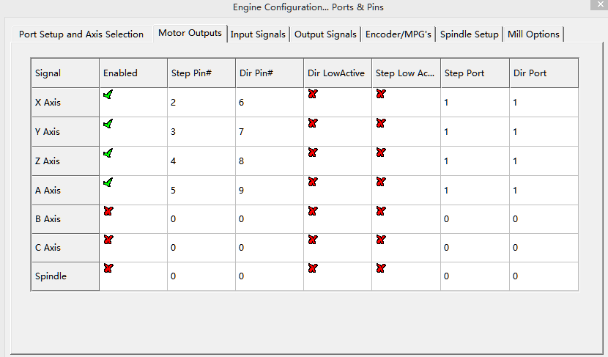

Figure 4-9. Stepper motor port settings dialog